Department Of Computer Science
Project Proposal Summer 26-27

Course Title | 00931 Advanced Programming in Web Technology | Section | E | Group | 1

- Institution and department : AIUB, BSc in CSE.
- Submission date : 17/10/26
- Team members: (The Beekeeper)
Name | Student ID
Sagar Biswas | 22-47929-2
Md. Minhazul Hassan | 23-53049-3

- Course Teacher : Sultanul Arifeen Hamim
- Project Title : MultiHAT Academy

- Purpose/Project Goal
A full-stack micro-credential & e-commerce platform that transforms technical notebooks into premium, verifiable digital learning products.

- Project Overview
MultiHAT Academy sells premium e-books with buyer-specific dynamic watermarks, offers paid web chapters and interactive quizzes, issues verifiable certificates of completion, and features a User Wallet ecosystem with Referral and Certification Showcase Rewards for organic growth. As both a revenue-generating platform and a university course project.

- Tech Stack
Layer | Technology | Purpose
Frontend | Next.js 15 · React 19 · TypeScript · Tailwind CSS 3 | SSG/SSR web application
UI Components | shadcn/ui · Radix UI · Lucide React | Accessible, composable component library
Backend | NestJS 11 · TypeScript | RESTful API server
Database | PostgreSQL 16 · Prisma ORM | Relational data storage
API | REST (JSON/HTTPS) | Frontend ↔ Backend communication
Payments | aamarPay | bKash · Nagad · Rocket · Cards
Auth | JWT + Passport.js · bcrypt | Stateless authentication + password hashing
Email | Resend | Transactional email delivery
PDFs | pdf-lib | Watermarked e-books + programmatic certificates
Validation | class-validator · class-transformer · Zod | Server-side DTO + client-side form validation
Scheduling | @nestjs/schedule | Cron jobs (showcase verification)
Markdown | react-markdown · remark-gfm · rehype-raw | Chapter content rendering
Charts | Recharts | Dashboard data visualisation
Security | Helmet · @nestjs/throttler | Security headers + rate limiting
Hosting | Vercel + DigitalOcean Droplet | Frontend CDN + backend VPS
DNS/CDN | Cloudflare (free plan) | DNS · DDoS protection · CDN
SSL | Let's Encrypt (API) · Cloudflare (frontend) | HTTPS certificates
Process Manager | PM2 | Production process management
CI/CD | GitHub Actions | Automated testing & deployment
Containerisation | Docker Compose | Local PostgreSQL development

- System Architecture
Architecture is not a single choice; it is a set of independent decisions across four dimensions. MultiHAT Academy makes a deliberate choice in each.
Dimension | Question | Decision | Rationale
Rendering Strategy | How and when is the HTML built? | Hybrid Rendering | Next.js 15 statically generates marketing and book-listing pages at build time Static Site (SSG) and server-renders user-specific pages per request Server-Side Rendering (SSR): dashboard, payment confirmation, certificate viewer
Application Structure | How is the backend organised? | Full-Stack Web App (Headless/Decoupled pattern) | One NestJS monolith (12 modules, single PM2 process, one PostgreSQL 16 database) serves one frontend exclusively via a REST API contract; frontend and backend are independently deployed
Delivery Philosophy | Is content pre-built or fetched live? | Jamstack | The Next.js frontend is pre-built and served from Vercel's global CDN. All dynamic behaviour (purchases, quizzes, wallet, auth) is delegated to the NestJS REST API; no backend logic lives inside the frontend
Infrastructure | Where does the code run? | VPS (backend) + CDN (frontend) | The API runs on a DigitalOcean Droplet (single VPS; no edge functions or serverless). The frontend static assets are served from Vercel's CDN, providing low-latency delivery globally for pre-rendered pages without edge computing for the API layer

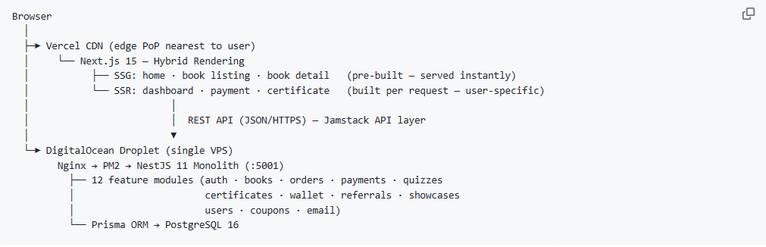
- How the four decisions work together

Not used: Microservices (overkill for current scale; a monolith is easier to deploy, debug, and maintain on a 1 GB Droplet), Edge Computing for the API (not needed; the API is not globally distributed; only the frontend CDN provides geographic edge delivery).
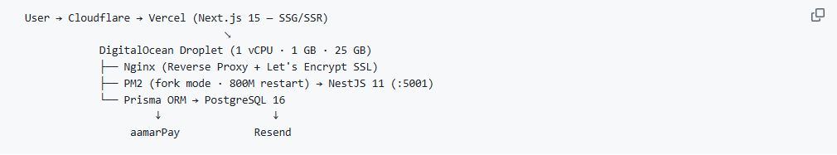
Infrastructure

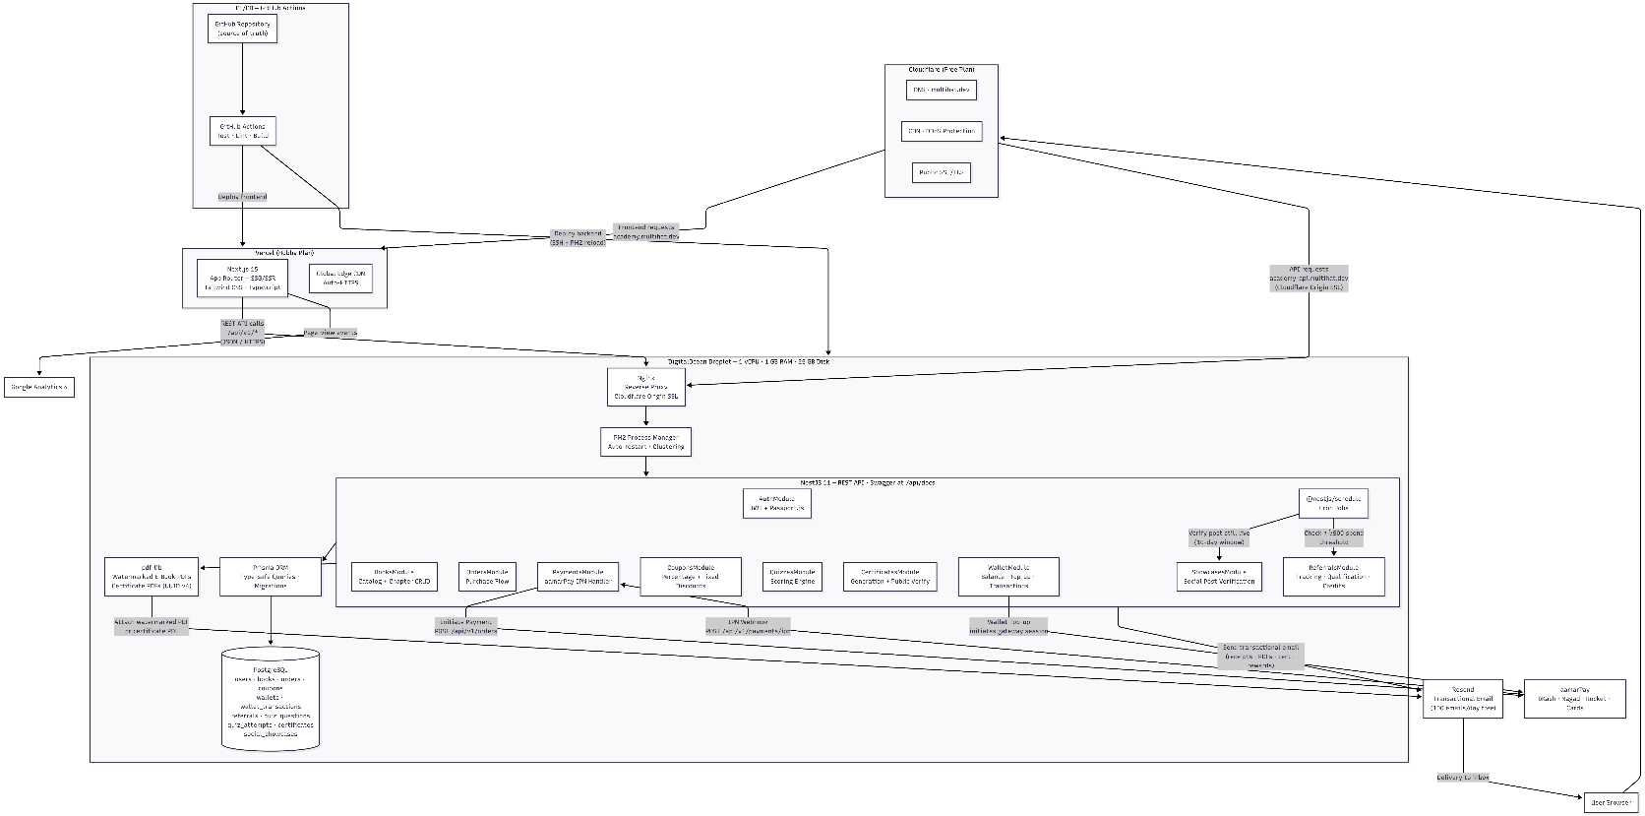
- System Architecture Diagram:

Live: 01-architecture-overview.png

- Key Features
- Premium E-books: Watermarked PDFs with buyer's email tiled diagonally on every page (opacity 0.065, -45°)
- Free Previews: First 4 chapters of each book available without login (configurable via chapterMetadata.isFree)
- Paid Web Chapters: Premium gated web content purchasable via Wallet or payment gateway
- Interactive Quizzes: Multiple-choice assessments per book (70% pass threshold; hardcoded)
- Verifiable Certificates: Programmatic PDF certificates (pdf-lib, A4 landscape) with public verification at /verify/:certID
- User Wallet: Cash-in only wallet for platform purchases; funded via aamarPay top-ups, referral credits, and showcase rewards
- Referral Program: Earn 100 BDT/$0.80 per qualified referral (referred user must spend ≥ 500 BDT/$4); 3-step state machine: PENDING → QUALIFIED → CREDITED
- Certification Showcase: Earn Wallet credits by sharing certifications on LinkedIn (100 BDT), Twitter/X (100 BDT), Facebook (80 BDT), and Instagram (80 BDT); 10-day automated cron verification via HTTP HEAD
- Local Payments: aamarPay integration (bKash, Nagad, Rocket, cards) with IPN webhook + idempotency guards
- Anti-Piracy: Dynamic watermarks, UTM-tracked links, Google Alerts
- Coupon System: Percentage and fixed-amount discount codes with includes_pdf flag; codes auto-normalised to UPPERCASE
- Dark Mode: Full dark/light theme support (next-themes)
- User Dashboard: Purchase history, quiz scores, certificates, wallet balance, showcase submissions
- Email Delivery: Automatic watermarked PDF and purchase receipt delivery via Resend
- Security: Helmet headers, global rate limiting (100 req/60s), login throttle (10/min), DTO whitelist validation, CORS strict origin, Swagger disabled in production

P.T.O
- User Types & Features
- Types of User
MultiHAT Academy has three distinct user types, determined by authentication state and database role:
Type | Auth State | Role | How to become one
Guest | Not logged in | — | Visit the site without an account
Registered User | JWT authenticated | USER | POST /auth/register (default role)
Admin | JWT authenticated | ADMIN | Role set manually via PATCH /users/:id/role or DB seed

- Common Features (Available to All Users; No Login Required)
These endpoints work without a JWT token:
Feature | Endpoint | Notes
Browse published books | GET /books | Paginated list
View book detail | GET /books/:slug | No ownership flags returned
Read free chapters | GET /books/:slug/chapters/:index | Only chapters where isFree: true
View chapter media | GET /books/:slug/media/* | SSRF + path-traversal guarded
Validate a coupon | GET /coupons/verify/:code | Returns discount type and value
Verify a certificate | GET /certificates/verify/:certId | Returns {valid, holderName, courseTitle, issueDate}
Download a certificate | GET /certificates/:certId/pdf | Returns 404 if revoked
Register | POST /auth/register | Accepts optional referralCode
Log in | POST /auth/login | Throttled: 10 attempts/minute
Refresh session | POST /auth/refresh | Uses refresh token

P.T.O
- Features by User Type
Registered User (Role.USER)
All common features above, plus:
Feature | Endpoint | Notes
View own profile | GET /users/me | {id, email, name, role, createdAt}
Update own name | PATCH /users/me | {name}
Book detail with ownership | GET /books/:slug | Returns isOwned, ownsPdf, hasPremiumPdf
Read paid chapters | GET /books/:slug/chapters/:index | Requires at least one PAID order for the book
Purchase a book | POST /orders | Gateway (aamarPay) or Wallet debit
View own orders | GET /orders/my | Full purchase history
Download watermarked e-book | GET /orders/:orderId/pdf | Ownership verified; PDF watermarked per buyer
Take a quiz | GET /quizzes/:bookSlug/questions | Requires PAID order; correct answers hidden
Submit quiz answers | POST /quizzes/:bookSlug/submit | Returns {score, total, outcome, certId?}; 70% = PASS → auto-issues certificate
View own certificates | GET /certificates/my | Ordered by date descending
Submit a showcase | POST /showcases/submit | 3-layer guard: SSRF → ownership → no duplicate
View own showcase submissions | GET /showcases/my | Includes verification status
Wallet balance | GET /wallet/balance | {balanceBdt, lifetimeEarned, lifetimeSpent}
Top up wallet | POST /wallet/topup | Initiates aamarPay payment → redirects to gateway
Confirm wallet top-up | POST /wallet/topup/confirm | Polls aamarPay search API as a fallback
Wallet transaction history | GET /wallet/transactions | Paginated (default 20 · max 100)
Get referral link | GET /referrals/code | {referralCode, referralLink}
Referral statistics | GET /referrals/stats | {total, pending, qualified, credited, totalEarned}

P.T.O
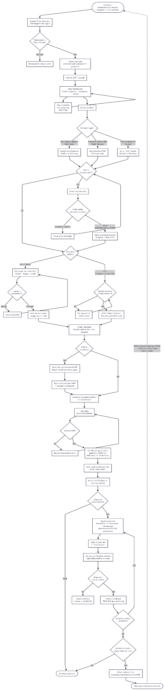

User Journey Diagram:
Live: 03-user-journey.png

- Admin (Role.ADMIN)
All registered user features above, plus exclusive admin-only access:
Feature | Endpoint | Notes
List all books (incl. unpublished) | GET /books/admin/all | Paginated (default 50 · max 200)
Create a book | POST /books | {title, slug, description, price, chapterMetadata}
Update a book | PATCH /books/:id | Toggle is_published, update price, metadata
List all coupons | GET /coupons | Ordered by created_at desc
Get a single coupon | GET /coupons/:id
Create a coupon | POST /coupons | Code auto-normalised to UPPERCASE; PERCENTAGE or FIXED
Update a coupon | PATCH /coupons/:id | All fields patchable; code re-normalised if changed
Delete a coupon | DELETE /coupons/:id | coupon_id set to NULL on existing orders (history preserved)
View all orders | GET /orders | Paginated (default 50 · max 100)
List all users | GET /users | Paginated (default 50 · max 100)
Change a user's role | PATCH /users/:id/role | {role: "USER" | "ADMIN"}
Book selector for quiz admin | GET /quizzes/admin/books | {id, title, slug, isPublished}
List questions with answers | GET /quizzes/admin/:bookSlug | Includes correct_answer + sort_order
Create a quiz question | POST /quizzes/admin/questions | correct_answer must be in options[]
Update a quiz question | PATCH /quizzes/admin/questions/:id | Validates correct_answer ∈ options
Delete a quiz question | DELETE /quizzes/admin/questions/:id | Returns {deleted: true}
Revoke a certificate | DB / Prisma Studio directly | Set is_valid = false; no dedicated API endpoint

P.T.O
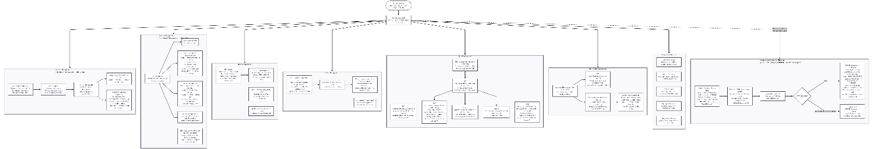
- Admin Workflow Diagram:

Live: 06-admin-workflow.png

- Data Model
The PostgreSQL database is managed via Prisma ORM. The schema is built around 11 core entities, designed with strict referential integrity (Cascade / SetNull) and financial safety (Decimal types, raw SQL atomic decrements).
- Enums

Enum | Values
Role | USER · ADMIN
OrderStatus | PENDING · PAID · FAILED · REFUNDED
PaymentMethod | GATEWAY · WALLET
DiscountType | PERCENTAGE · FIXED
QuizResult | PASS · FAIL
ReferralStatus | PENDING · QUALIFIED · CREDITED
ShowcasePlatform | LINKEDIN · TWITTER · FACEBOOK · INSTAGRAM
ShowcaseStatus | PENDING · VERIFIED · REJECTED
WalletTransactionType | TOPUP · PURCHASE · REFERRAL_CREDIT · SHOWCASE_CREDIT

P.T.O
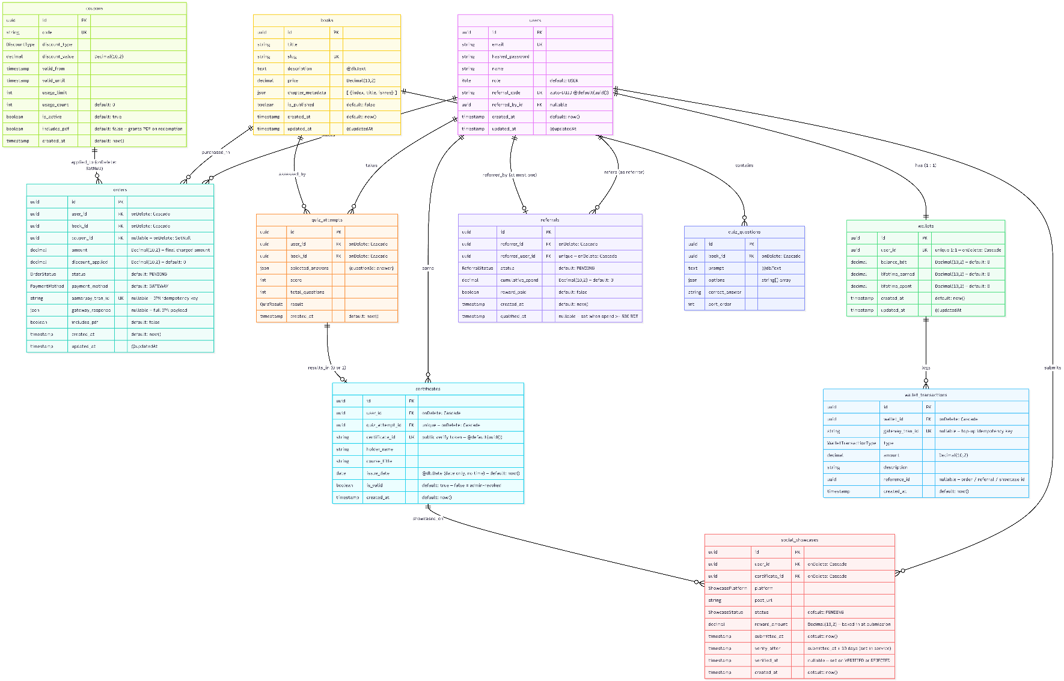
- Entity Relationship Diagram

Live: 04-data-model.png
- Constraints & Cascade Rules
Table | Column / Index | Type | Behaviour
orders | coupon_id FK | onDelete: SetNull | Deleting a coupon nulls coupon_id; order history preserved
orders | user_id FK | onDelete: Cascade | Deleting a user cascades to their orders
orders | book_id FK | onDelete: Cascade | Deleting a book cascades to its orders
orders | aamarpay_tran_id | @unique | Prevents duplicate IPN processing
quiz_questions | book_id FK | onDelete: Cascade | Deleting a book cascades to its quiz questions
quiz_attempts | user_id FK | onDelete: Cascade | Deleting a user cascades to their attempts
quiz_attempts | book_id FK | onDelete: Cascade | Deleting a book cascades to its attempts
certificates | quiz_attempt_id | @unique | One certificate per quiz attempt maximum
certificates | quiz_attempt_id FK | onDelete: Cascade | Deleting the attempt cascades to the certificate
certificates | user_id FK | onDelete: Cascade | Deleting a user cascades to their certificates
coupons | (no FK) | — | No cascades; referenced via orders.coupon_id (SetNull)
wallets | user_id | @unique | Enforces 1:1 relationship with users
wallets | user_id FK | onDelete: Cascade | Deleting a user cascades to their wallet
wallet_transactions | wallet_id FK | onDelete: Cascade | Deleting a wallet cascades to its transactions
wallet_transactions | gateway_tran_id | @unique nullable | Idempotency guard for top-up IPN webhooks (P2002 silently ignored)
referrals | referred_user_id | @unique | A user can be referred at most once
referrals | referrer_id FK | onDelete: Cascade | Deleting referrer cascades to referral records
referrals | referred_user_id FK | onDelete: Cascade | Deleting referred user cascades to referral records
social_showcases | (user_id, certificate_id, platform) | @@unique | One reward per platform per certificate per user
social_showcases | user_id FK | onDelete: Cascade | Deleting a user cascades to their showcase submissions
social_showcases | certificate_id FK | onDelete: Cascade | Deleting a certificate cascades to its showcases

- Key Design Notes
Concern | Detail
All PKs | @id @default(uuid()) @db.Uuid; PostgreSQL native UUID
Financial fields | All monetary values use Decimal(10,2); no floating point
certificate_id vs id | certificates.id = internal DB PK · certificates.certificate_id = public verify token (also a UUID, auto-generated separately)
referral_code | Every user gets a unique referral code at registration; @default(uuid())
issue_date | @db.Date; stored as a pure date with no time component
social_showcases.reward_amount | Baked in at INSERT time from PLATFORM_REWARDS constant; not recomputed by cron
social_showcases.verified_at | Set on BOTH VERIFIED and REJECTED terminal states
coupons has no updated_at | Intentional; no @updatedAt in schema
quiz_questions has no timestamps | Intentional; no created_at or updated_at in schema
Wallet debit atomicity | Uses raw SQL UPDATE wallets SET balance_bdt = balance_bdt - :amt WHERE balance_bdt >= :amt; eliminates TOCTOU race

- REST API Endpoints
All endpoints are prefixed with /api/v1. Global rate limit: 100 requests per 60 seconds per IP.
Group | Method | Endpoint | Auth | Notes
Auth | POST | /auth/register | No | Accepts optional referralCode
 | POST | /auth/login | No | Throttled: 10 attempts/minute
 | POST | /auth/refresh | Refresh token
Books | GET | /books | No | Published only · paginated (default 20 · max 100)
 | GET | /books/admin/all | Admin | All books incl. unpublished (default 50 · max 200)
 | GET | /books/:slug | Optional | Returns isOwned, ownsPdf, hasPremiumPdf, requiresGatewayPayment
 | GET | /books/:slug/chapters/:index | Optional | Free chapters: no auth · Paid: 403 without order
 | GET | /books/:slug/media/* | No | Image serving with SSRF + path-traversal guard
 | POST | /books | Admin | Create book
 | PATCH | /books/:id | Admin | Update book fields
Coupons | GET | /coupons/verify/:code | No | Learner validates coupon before checkout
 | GET | /coupons | Admin | List all coupons
 | GET | /coupons/:id | Admin | Single coupon
 | POST | /coupons | Admin | Create; code UPPER-normalised
 | PATCH | /coupons/:id | Admin | Partial update
 | DELETE | /coupons/:id | Admin | Soft cascade; SetNull on orders
Orders | POST | /orders | Yes | Create order (gateway or wallet)
 | GET | /orders/my | Yes | Own order history
 | GET | /orders/:orderId/pdf | Yes | Stream watermarked e-book PDF
 | GET | /orders | Admin | All orders paginated
Payments | POST | /payments/ipn | Webhook | aamarPay IPN; idempotent, signature-verified
 | GET/POST | /payments/success | Redirect | Gateway return; verifies via search API
 | GET/POST | /payments/fail | Redirect | Marks order FAILED, releases coupon
 | GET/POST | /payments/cancel | Redirect | Same as fail with reason "cancelled"
Quizzes | GET | /quizzes/:bookSlug/questions | Yes | Without correct answers (requires PAID order)
 | POST | /quizzes/:bookSlug/submit | Yes | Returns score + optional certificate
 | GET | /quizzes/admin/books | Admin | Book selector list
 | GET | /quizzes/admin/:bookSlug | Admin | Questions with correct answers
 | POST | /quizzes/admin/questions | Admin | Create question
 | PATCH | /quizzes/admin/questions/:id | Admin | Update question
 | DELETE | /quizzes/admin/questions/:id | Admin | Delete question
Certificates | GET | /certificates/my | Yes | Own certificates
 | GET | /certificates/:certId/pdf | No | Re-generate & stream certificate PDF
 | GET | /certificates/verify/:certId | No | Public verification
Users | GET | /users/me | Yes | Own profile
 | PATCH | /users/me | Yes | Update own name
 | GET | /users | Admin | All users paginated (default 50 · max 100)
 | PATCH | /users/:id/role | Admin | Role promotion/demotion
Wallet | GET | /wallet/balance | Yes | {balanceBdt, lifetimeEarned, lifetimeSpent}
 | POST | /wallet/topup | Yes | Initiate top-up → aamarPay URL
 | POST | /wallet/topup/confirm | Yes | Confirm via aamarPay search API
 | GET | /wallet/transactions | Yes | Paginated history (default 20 · max 100)
Referrals | GET | /referrals/code | Yes | {referralCode, referralLink}
 | GET | /referrals/stats | Yes | {total, pending, qualified, credited, totalEarned}
Showcases | POST | /showcases/submit | Yes | 3 guards: SSRF → ownership → duplicate
 | GET | /showcases/my | Yes | Own submissions with status
Health | GET | /healthz | No | {status: "ok", uptime}

- CI/CD Pipeline
Triggered on push to main via GitHub Actions:
Job | Steps
build-and-test | npm ci → prisma generate → lint → test → test:e2e (backend) · npm ci → build (frontend)
deploy-backend | SSH to Droplet → git pull → npm ci → prisma generate → prisma migrate deploy → npm run build → npm prune --omit=dev → pm2 restart
health-check | Wait 10s → curl GET /healthz → fail pipeline if non-200

P.T.O
- Diagram:
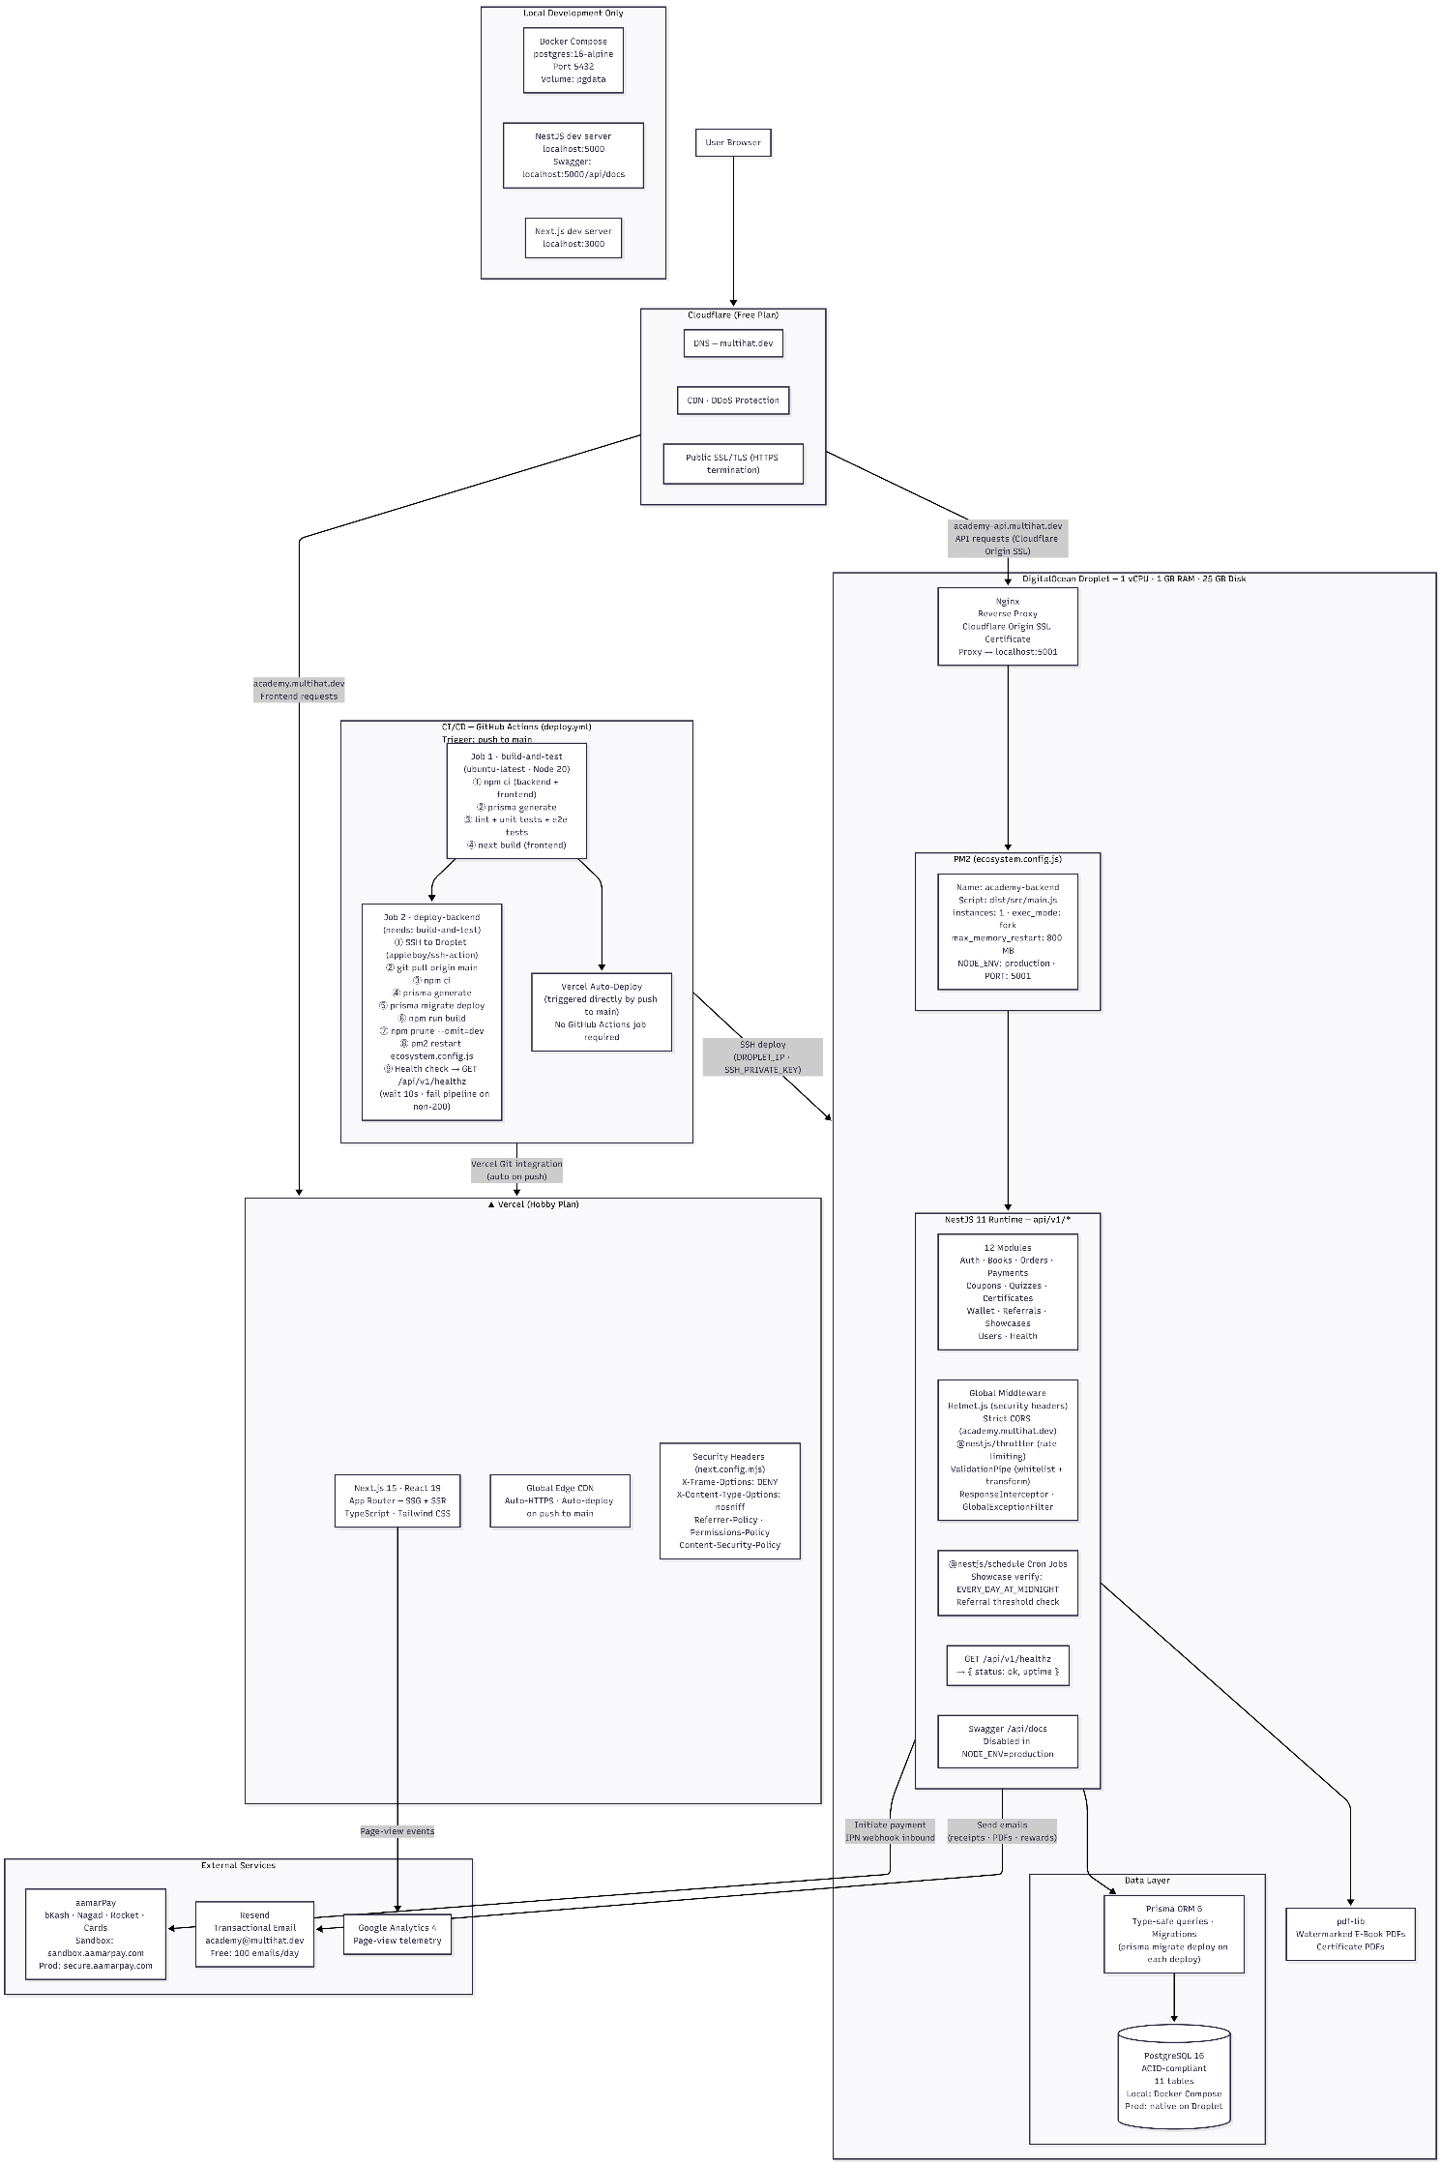
Live: 05-deployment-topology.png

- Budget
Item | Cost
Domain (academy.multihat.dev) | $0; free subdomain
Cloudflare DNS & CDN | $0; free plan
DigitalOcean Droplet | $0 additional; existing
Vercel Hosting | Free (Hobby)
Resend Email | Free (100/day)
Let's Encrypt SSL | $0; free
aamarPay Fees | ~2% per transaction
Total additional fixed cost: $0/year

- Certification Design:
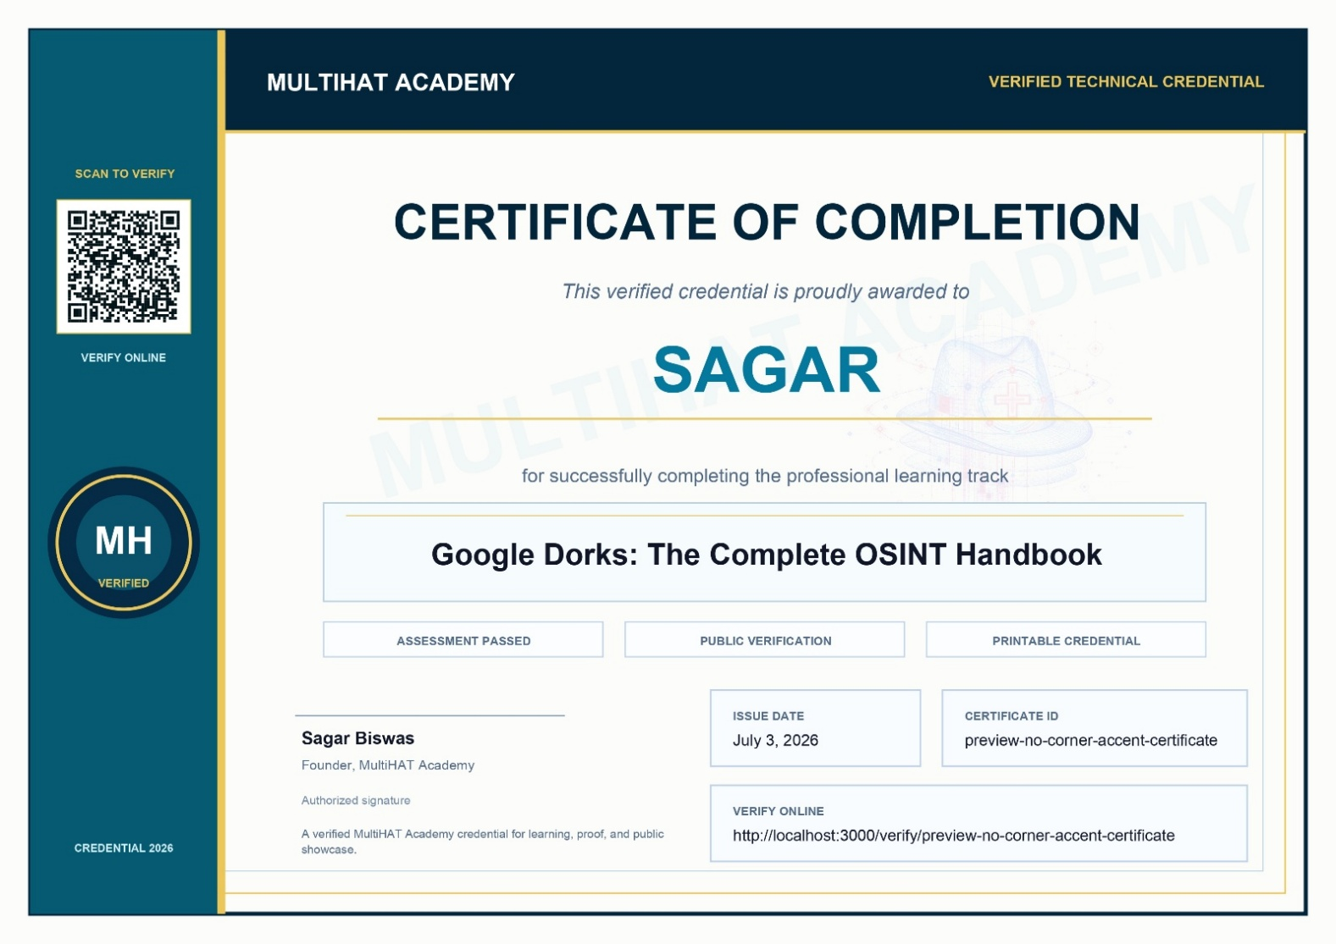

- Certificate Issuance Flow Diagram:
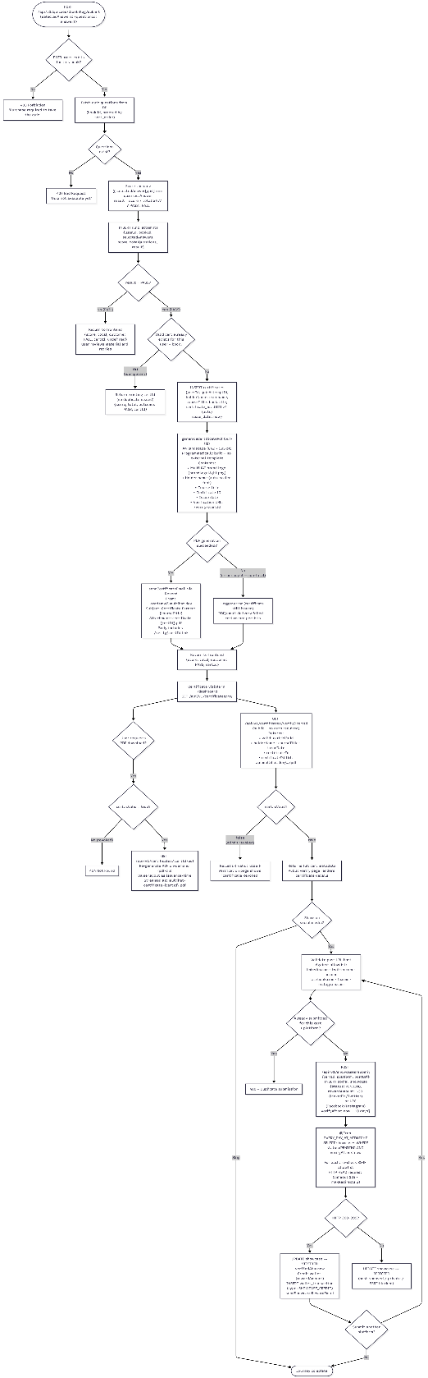

Live: 07-certificate-issuance-flow.png

- All 8+7 diagrams are available on: Diagrams; For high-quality, please download the diagrams.
- GitHub Repository: SagarBiswas-MultiHAT/Multihat-Academy

---------------------- X ----------------------

